USER MANUAL FOR RTCUDA IDE

(Bonus Assignment)

**Course: GP GPU Programming**

**Teacher: Dr. Ayaz**

**Azam Khan & M.Zubair**

1. 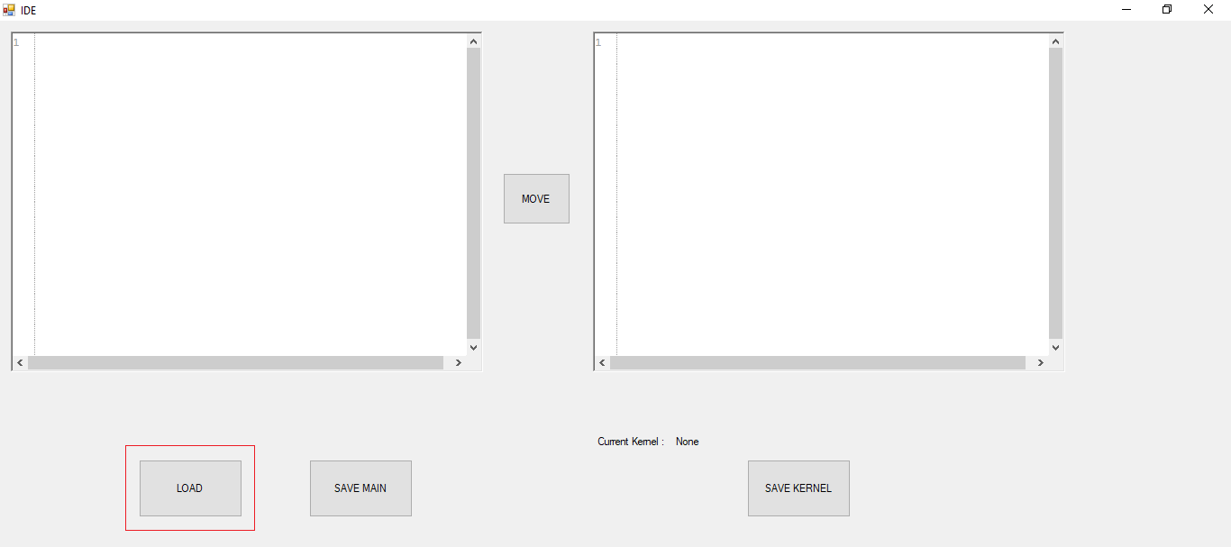**Open ide and click on load to choose a file from hard drive or paste your code in the left panel text area**
2. **Choose your file and click open**

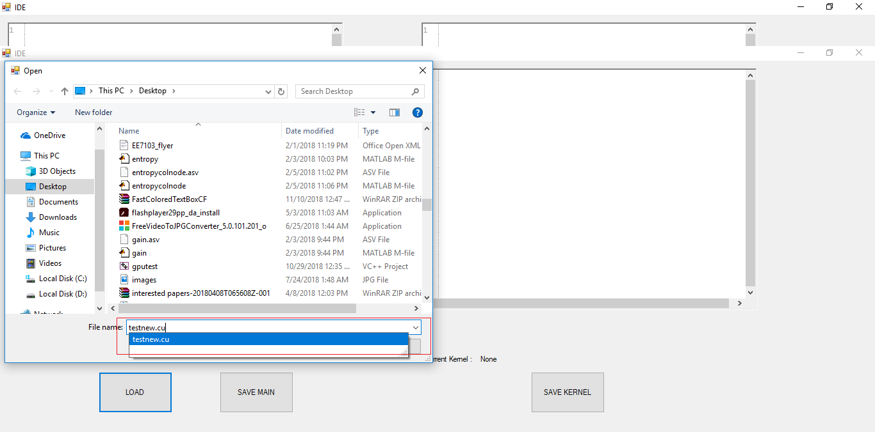

1. **Select the area as your kernel**

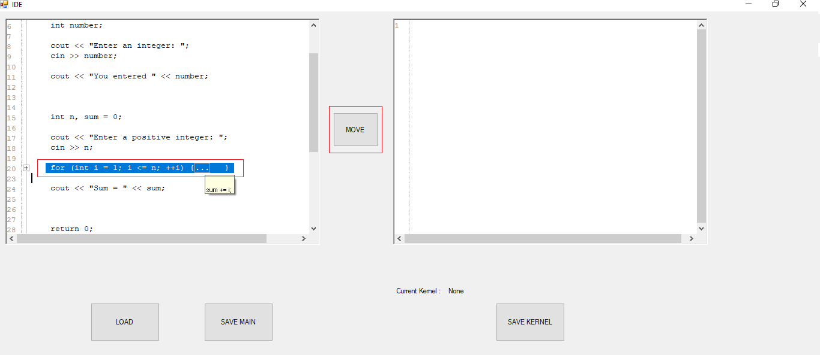

1. **Click on move to separate it from main section and input the kernel name for the new section**

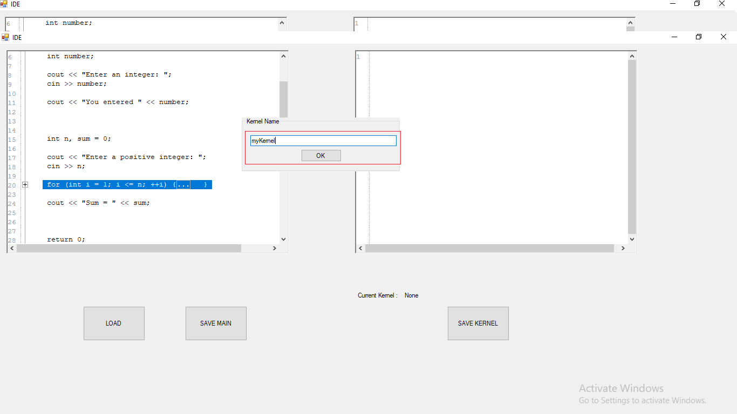

1. **A reference of this kernel is create in main now click on save kernel to save the kernel file and save main to save main file**

